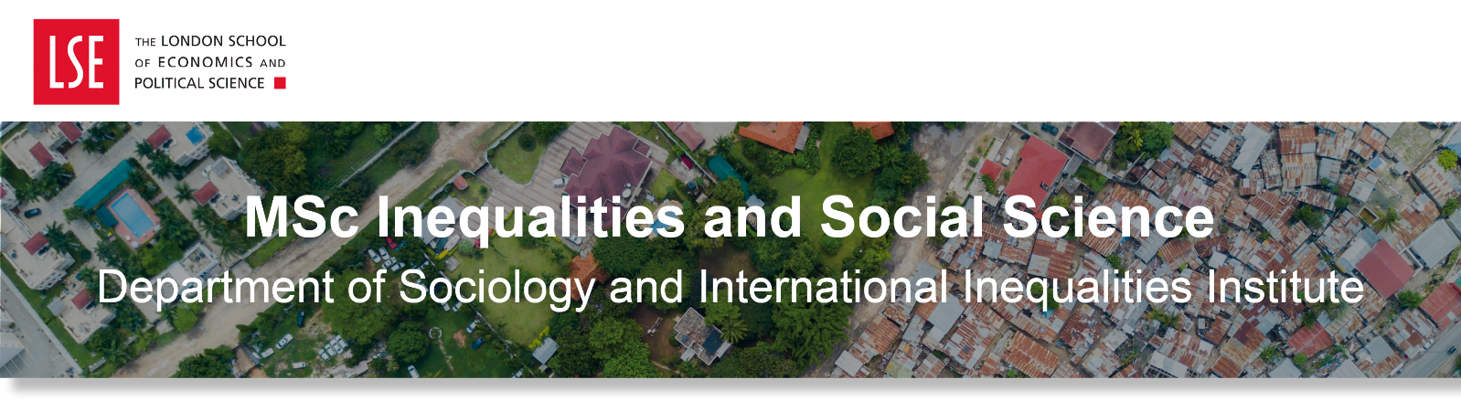
Dear,

September might still seem like a long way away, but we are already starting the steady countdown to your arrival and can’t wait to meet you!

Whether you will be joining us straight from your current undergraduate studies at another institution, are currently in the workplace or maybe enjoying some travel or volunteering opportunities before joining us here in September, there is a range of academic support in place at LSE to help you settle into the programme and throughout your time studying at LSE. Read on for information about academic mentors, study skills, English language support and more!



Your Academic Mentor
All students will be assigned an Academic Mentor, who will be full-time member of academic staff within the Department of Sociology or the International Inequalities Institute who can advise and help you with any academic or welfare issues that may arise. You’ll be invited to meet them during Welcome and will discuss your course selection with them during your first weeks. As the term progresses, you can speak with your academic mentor about readings, assessments and how your studies are going. We encourage students to keep in regular contact with their academic mentors, including booking into their regular office hours. Academic mentoring is an integral part of education at LSE and critical to building an inclusive scholarly community for everyone. Information on the roles and responsibilities of mentor and mentee can be found on the My Academic Mentor webpage.

LSE LIFE
LSE LIFE is LSE's centre for academic, personal, and professional development. They offer a plethora of workshops and other unique events where you can learn more about the skills and personal interests you choose to explore. They offer one-to-one sessions to help you discover your strengths, develop your skills, and bring them together to reach your goals. Example workshops include “Define, refine and practise your literature search” and “Critically explore the readings in your courses”, as well as a whole host of MSc dissertation specific workshops and writing retreats. Find out more about LSE LIFE here.


Digital Skills Lab
LSE’s Digital Skills Lab is our centre hub that provides training and support to develop key skills you may need to support your personal and professional development. Workshops include “Excel Essentials”, “Self-study HTML”, “Python for Data Science” and “Stat Fundamentals”. All students can use the service, which also includes 1-2-1 appointments with Digital Skills advisors and online resources that you can access and go through in your own time. Find out more here!

LSE Careers
LSE Careers can help guide and support you throughout your time at LSE. They provide a range of careers services and events both online, face-to-face and through one-to-one appointments. To find out more about the support offered visit the LSE Careers website.
We expect students to go into a wide variety of fields who are interested in addressing inequalities, including government, NGOs, politics, public administration, the social and health services, advertising, journalism, other areas of the media, law, publishing, industry, personnel, and management. Read about our previous students’ career destinations below.

Ana Santellanes, 2016 graduate (Mexico)
Ana currently works as advisor at the Ministry of Agrarian, Territorial and Urban Development of Mexico. Ana describes her studies at LSE as one of the best experiences and challenges in her life. It gave her a multidisciplinary perspective on the inequalities phenomenon, and how it relates to every sphere of human life.

Louise Russell-Prywata, 2019 graduate and an Atlantic Fellow for Social and Economic Equity (UK)
Louise is the Director of Policy and Programs at OpenOwnership, a global initiative driving technology and policy changes that increase corporate transparency. Louise leads a program of work supporting governments to establish open data registers of the people who benefit or control companies based in their jurisdictions.


Mauricio Renteria Gonzales, 2020 graduate (Peru)
Mauricio is a sociologist and researcher at the Institute of Peruvian Studies (Peru). He has published articles and co-authored books around different forms of inequalities and social class. In 2021 he was awarded the President's Doctoral Scholarship at the University of Manchester to pursue a PhD in Sociology.

For more career destinations of our previous students, please see our website.

English-Language Skills
If English is not your first language, there are plenty of ways you can improve and practise using the English language for your academic work. Online courses, workshops and one-to-one support are provided by the Language Centre. The Language Centre runs English for Academic Purpose workshops that you can take part in such as pronunciation, presentation skills and argumentation. Find out more here! If you are interested in learning a new language, or improving your existing level in a particular language, you can take classes outside of your degree programme as an addition to your studies at the LSE Language Centre.



We know you may be keen to find out more about your programme, so do keep an eye out for our next few emails where we’ll be sharing more information about any suggested readings, course selection and more!

Warm wishes,
Vivienne and Adeel

Vivienne Codjoe and Adeel Parvez
MSc Programme Managers | Department of Sociology
The London School of Economics and Political Science
Houghton Street, London WC2A 2AE
e: sociology.msc@lse.ac.uk
lse.ac.uk



