

Dear Offer Holder,

The LSE Department of Sociology is very much looking forward to your enrolment. To get you introduced, please read below to find out more about your programme and the department.



**MSc Political Sociology**

The London School of Economics and Political Science was founded over 120 years ago by the Fabian socialists – leading social reformers who were deeply committed to intellectual and empirical rigour. For them, reform and rigour went hand in hand.

It is testament to the power of this vision that the university they founded and the graduates it has produced have been instrumental in influencing politics and social movements, as well as public policy and social scientific inquiry. Through this, it has helped shape fundamental political change in many countries around the world.

The MSc in Political Sociology very much continues in this spirit, providing analytical tools and empirical knowledge that should serve you well, whether your interest is in pursuing social and political changes, resisting them, or simply understanding them better.

The programme seeks to provide a strong core curriculum that explores the underlying drivers of some major social and political developments, as well as the flexibility to meet individual interests through a wide range of optional courses around LSE. The programme attracts students from a great many countries, many with political experiences of their own. Our central focus is learning through formal education, but we hope that you will also have much to learn from each other.

**The Department of Sociology**

You are about to embark on an amazing journey, full of excitement, challenges, new knowledge, experiences, friends, and opportunities. The Department of Sociology is a community that brings people together from different parts of the world, speaking different languages and bringing their knowledge and unique experiences. This community includes your Programme Director and Programme Manager, the Sociology professional services staff, academic staff and all LSE associated teachers. We are here to support you in pursuing your academic and professional goals.

The Programme Manager for your degree will be your first point of contact for any queries throughout your time at LSE. Whether you need to know about the programme format, how to make your course choices, assessment matters, have general feedback, or if you’re just not sure who to contact at the School on any matter, please do get in contact and we will do our best to assist, or direct you the relevant colleague, or team.

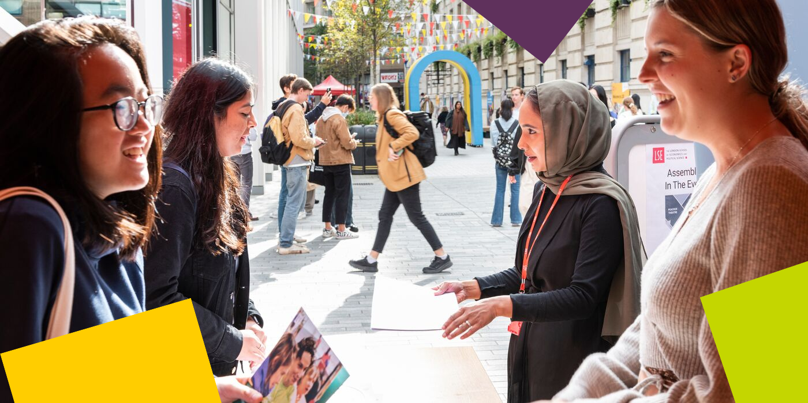

**LSE Welcome**

Please note the date of the start of **LSE Welcome**, which is a programme of activities and events in-person on campus that will help you become part of LSE: **Monday 23 September – Friday 27 September 2024.** During this week, the department will be running a series of sessions that will allow you to learn about what to expect from your LSE education, prepare for the course selection process, and interact with your cohort. It will be an opportunity for you to get to know us better along with your classmates and the rest of the Department of Sociology community. **Please ensure you keep these dates free in your diary***.*

**Further Communications**

To make your admissions process as smooth as possible, look out for emails from [LSE's](https://lse.bmetrack.com/c/l?u=BD092BC&e=11E595F&c=ACD70&t=0&email=kpM4Fw09Tnma1TTtF%2BQvcA%3D%3D&seq=1)[Graduate Admissions Team](https://lse.bmetrack.com/c/l?u=BD092BC&e=11E595F&c=ACD70&t=0&email=kpM4Fw09Tnma1TTtF%2BQvcA%3D%3D&seq=2) who will continue to send you regular updates and reminders. The latest admission updates can be found on the School’s [News and Events webpage](https://www.lse.ac.uk/study-at-lse/Graduate/News). Be sure to pay close attention to the inevitable administrative priorities, as some messages will require action from you!

We will continue to be in contact with more programme information via these newsletters throughout the summer, and you can keep up to date with us [via our Offer Holders webpages.](https://www.lse.ac.uk/sociology/offer-holders/offer-holders)

Congratulations again, and we very much look forward to welcoming you and supporting you throughout your journey at LSE.

If you have any questions, please don’t hesitate to get in touch with us.

Best Wishes,

**Dr Robin Archer**

**Programme Director for MSc Political Sociology 2023-24**

**Department of Sociology**

The London School of Economics and Political Science

Houghton Street, London WC2A 2AE

e: [r.archer@lse.ac.uk](mailto:r.archer@lse.ac.uk)

**lse.ac.uk**

[](https://www.lse.ac.uk/)

[Twitter](https://twitter.com/LSEnews) [Facebook](https://www.facebook.com/lseps)  [Instagram](https://www.instagram.com/londonschoolofeconomics/)  [LinkedIn](https://www.linkedin.com/school/london-school-of-economics)  [](https://www.youtube.com/channel/UCK08_B5SZwoEUk2hDPMOijQ) [Tik Tok](https://www.tiktok.com/@lse)