

Dear Offer Holder,

The LSE Department of Sociology is very much looking forward to your enrolment. To get you introduced, please read below to find out more about your programme and the department.

MSc Sociology
The MSc Sociology is at the foundation of the department's graduate programmes, and we are delighted that our core disciplinary programme continues to thrive and to welcome new generations of sociologists.
This programme attracts a diverse group of students, ranging from those who have studied the discipline before and are hoping to deepen their sociological knowledge and practice, to those who have studied a related discipline and now find their interests converging on sociology for the first time. We offer courses tailored to both groups and recommend that you consider your options carefully, in light of your prior knowledge and experience of the discipline.
We believe that sociology offers a rich mixture of theoretical and empirical knowledge, and in our own practice as faculty we strive to produce research that is fully engaged with substantive questions and grounded in political debates. We encourage you to develop your own practice as sociologists in the same way, and for this reason you are required to take at least one course in research methods during your year (you can, of course, take more). This will support you in researching and writing your dissertation. Besides the dissertation and methods courses, we offer a broad range of option courses that we hope cater fully for our diverse student population.

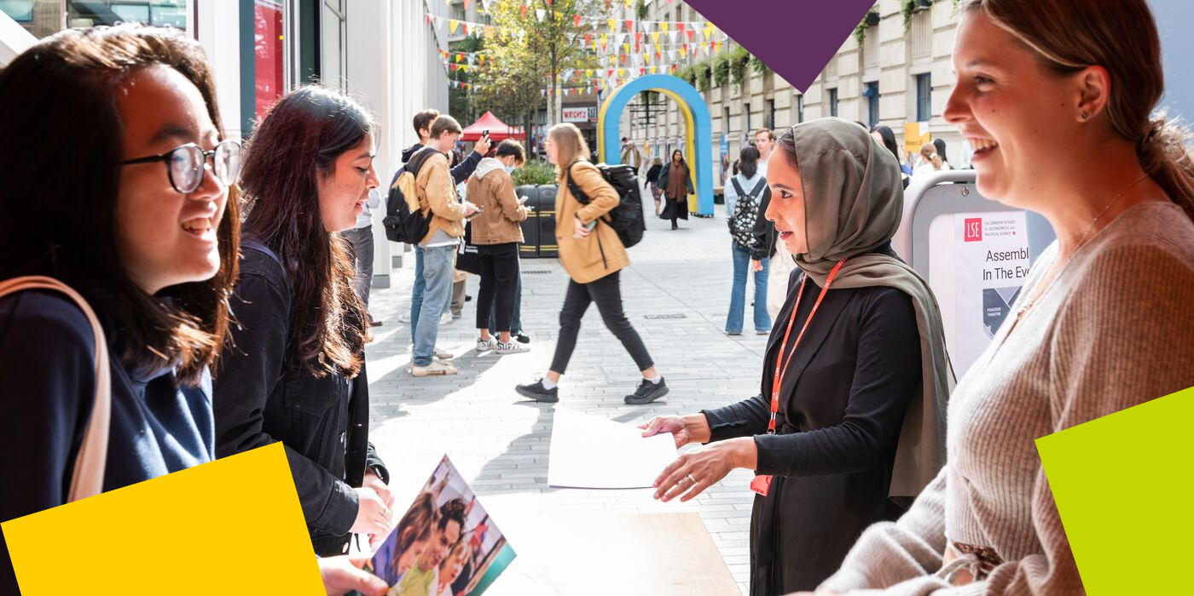

The Department of Sociology
You are about to embark on an amazing journey, full of excitement, challenges, new knowledge, experiences, friends, and opportunities. The Department of Sociology is a community that brings people together from different parts of the world, speaking different languages and bringing their knowledge and unique experiences. This community includes your Programme Director and Programme Manager – and the Sociology professional services staff, academic staff and associated teachers. We are here to support you in pursuing your academic and professional goals.

The Programme Manager for your degree will be your first point of contact for any queries throughout your time at LSE. Whether you need to know about the programme format, how to make your course choices, assessment matters, have general feedback, or if you’re just not sure who to contact at the school on any matter, please do get in contact and we will do our best to assist, or direct you the relevant colleague or team.

LSE Welcome
Please note the date of the start of LSE Welcome, which is a programme of activities and events in-person on campus that will help you become part of LSE: Monday 23 September – Friday 27 September 2024. During this week, the department will be running a series of sessions that will allow you to learn about what to expect from your LSE education, prepare for the course selection process, and interact with your cohort. It will be an opportunity for you to get to know us better along with your classmates and the rest of the Department of Sociology community. Please ensure you keep these dates free in your diary.

Further Communications
To make your admissions process as smooth as possible, look out for emails from LSE's Graduate Admissions Team who will continue to send you regular updates and reminders. The latest admission updates can be found on the School’s News and Events webpage. Be sure to pay close attention to the inevitable administrative priorities, as some messages will require action from you!
We will continue to be in contact with more programme information via these newsletters throughout the summer, and you can keep up to date with us via our Offer Holders webpages.
Congratulations again, and we very much look forward to welcoming you and supporting you throughout your journey at LSE.
If you have any questions, please don’t hesitate to get in touch with us.
Best wishes,
Professor Monika Krause
Programme Director for MSc Sociology
Department of Sociology
The London School of Economics and Political Science
Houghton Street, London WC2A 2AE
e: m.krause@lse.ac.uk



