Dear Offer Holder,

The LSE Department of Sociology and International Inequalities Institute is very much looking forward to your enrolment. To get you introduced, please read below to find out more about your programme, the department, and the institute.

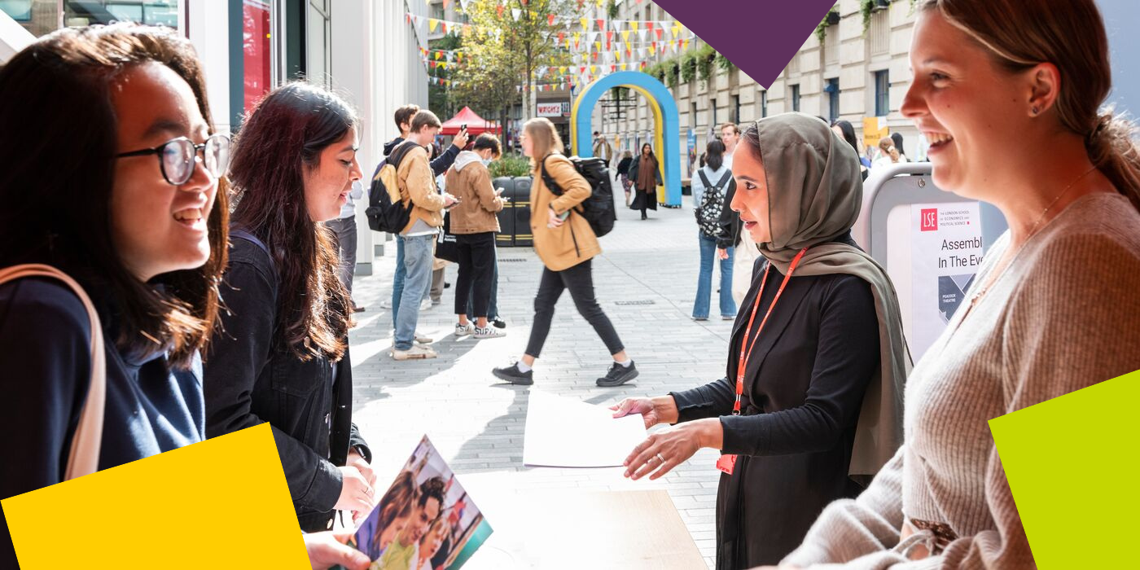  
**MSc Inequalities and Social Science**  
The MSc programme is run in collaboration between the Department of Sociology and LSE’s International Inequalities Institute. Through our wide-ranging programme, you will develop theoretical awareness of the different meaning of inequality in a fully international context. While the programme is housed by the Department of Sociology, we know most of you will not have a background in sociology – indeed our mix of students is one of the most exciting features of our programme – and you should be assured that intellectually, the MSc is very much orientated toward an interdisciplinary social scientific analysis of inequality.

Our MSc programme plays a central role in the work at the III, one of the world’s largest and most dynamic institutes focusing on the major global challenge of inequality, and I would like you to see yourself as a full member of both the department and institute! Together, we are confident you will have a unique and stimulating experience. Certainly, I hope you will take advantage of the chance to interact with the large and vibrant research community and the extensive range of events and seminars that are on offer.

You are about to embark on an amazing journey, full of excitement, challenges, new knowledge, experiences, friends, and opportunities. A community that brings people together from different parts of the world, speaking different languages and bringing their knowledge and unique experiences. This community includes both academic and professional services staff within the Department of Sociology and LSE’s Inequalities Institute. We are happy to be there to support you in pursuing your academic and professional goals.

The Programme Manager for your degree will be your first point of contact for any queries throughout your time at LSE. Whether you need to know about the programme format, how to complete your course selection, assessment matters, have general feedback, or if you’re just not sure who to contact at the school on any matter, please do get in contact and we will do our best to assist, or direct you the relevant colleague or team.

  
**LSE Welcome**

Please note the date of the start of **LSE Welcome**, which is a programme of activities and events in-person on campus that will help you become part of LSE: **Monday 23 September – Friday 27 September 2024.** During this week, the department will be running a series of sessions that will allow you to learn about what to expect from your LSE education, prepare for the course selection process, and interact with your cohort. It will be an opportunity for you to get to know us better along with your classmates and the rest of the Department of Sociology community. **Please ensure you keep these dates free in your diary***.*

**Further Communications**

To make your admissions process as smooth as possible, look out for emails from [LSE's](https://lse.bmetrack.com/c/l?u=BD092BC&e=11E595F&c=ACD70&t=0&email=kpM4Fw09Tnma1TTtF%2BQvcA%3D%3D&seq=1)[Graduate Admissions Team](https://lse.bmetrack.com/c/l?u=BD092BC&e=11E595F&c=ACD70&t=0&email=kpM4Fw09Tnma1TTtF%2BQvcA%3D%3D&seq=2) who will continue to send you regular updates and reminders. The latest admission updates can be found on the School’s [News and Events webpage](https://www.lse.ac.uk/study-at-lse/Graduate/News). Be sure to pay close attention to the inevitable administrative priorities, as some messages will require action from you!

We will continue to be in contact with more programme information via these newsletters throughout the summer, and you can keep up to date with us via [our Offer Holders webpages.](https://www.lse.ac.uk/sociology/offer-holders/offer-holders)

Congratulations again, and we very much look forward to welcoming you and supporting you throughout your journey at LSE.

If you have any questions, please don’t hesitate to get in touch with us.

Best Wishes,

**Professor Sam Friedman**

**Programme Director for MSc Inequalities and Social Science**

**Department of Sociology**

The London School of Economics and Political Science

Houghton Street, London WC2A 2AE

e: [s.e.friedman@lse.ac.uk](mailto:s.e.friedman@lse.ac.uk)

[](https://www.lse.ac.uk/)

[Twitter](https://twitter.com/LSEnews) [Facebook](https://www.facebook.com/lseps)  [Instagram](https://www.instagram.com/londonschoolofeconomics/)  [LinkedIn](https://www.linkedin.com/school/london-school-of-economics)  [](https://www.youtube.com/channel/UCK08_B5SZwoEUk2hDPMOijQ) [Tik Tok](https://www.tiktok.com/@lse)