

Dear Offer Holder,

The LSE Department of Sociology is very much looking forward to your enrolment. To get you introduced, please read below to find out more about your programme and the department.


MSc Culture and Society
MSc Culture and Society has a strong tradition of wide-ranging, creative, and innovative explorations of cultural processes. Part of the excitement of this degree is that each year has been entirely different and unpredictable, its character and dynamics arising from the unique individual and collaborative interests each cohort brings to it.
Clearly, ‘culture’ is a broad, complex, and often confusing umbrella term, covering a multitude of research objects and approaches. The aim of the degree is not comprehensive coverage of all that ‘culture’ can mean, but support for your own investigations, and some maps (theoretical, methodological, and substantive) to help you find your way through the impossible landscape of culture. Our core course is designed to help you build these maps through reading and discussion of both analytical approaches and case studies of cultural research, and we will help you choose additional option courses that can develop your own intellectual agenda.

The Department of Sociology
You are about to embark on an amazing journey, full of excitement, challenges, new knowledge, experiences, friends, and opportunities. The Department of Sociology is a community that brings people together from different parts of the world, speaking different languages and bringing their knowledge and unique experiences. This community includes your Programme Director and Programme Manager – and the Sociology professional services staff, academic staff and all LSE associated teachers. We are here to support you in pursuing your academic and professional goals.

The Programme Manager for your degree will be your first point of contact for any queries throughout your time at LSE. Whether you need to know about the programme format, how to make your course choices, assessment matters, have general feedback, or if you’re just not sure who to contact at the school on any matter, please do get in contact and we will do our best to assist, or direct you the relevant colleague or team.

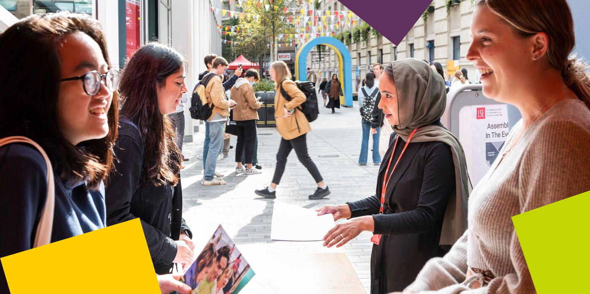

LSE Welcome
Please note the date of the start of LSE Welcome, which is a programme of activities and events that will help you become part of LSE: Monday 23 September – Friday 27 September 2024

During this week, the department will be running a series of sessions that will allow you to learn about what to expect from your LSE education, prepare for the course selection process, and interact with your cohort. It will be an opportunity for you to get to know us better along with your classmates and the rest of the Department of Sociology community. Please ensure you keep these dates free in your diary.

Further Communications
To make your admissions process as smooth as possible, look out for emails from LSE's Graduate Admissions Team who will continue to send you regular updates and reminders. The latest admission updates can be found on the School’s News and Events webpage. Be sure to pay close attention to the inevitable administrative priorities, as some messages will require action from you!

We will continue to be in contact with more programme information via these newsletters throughout the summer, and you can keep up to date with us via our Offer Holders webpages.

Congratulations again, and we very much look forward to welcoming you and supporting you throughout your journey at LSE.

If you have any questions, please don’t hesitate to get in touch with us.

Best Wishes,

Dr Jana Melkumova-Reynolds
Programme Director for MSc Culture and Society, Department of Sociology
The London School of Economics and Political Science
Houghton Street, London WC2A 2AE
e: y.m.reynolds@lse.ac.uk



