

Dear Offer Holder,

The LSE Department of Sociology is very much looking forward to your enrolment. To get you introduced, please read below to find out more about your programme and the department.

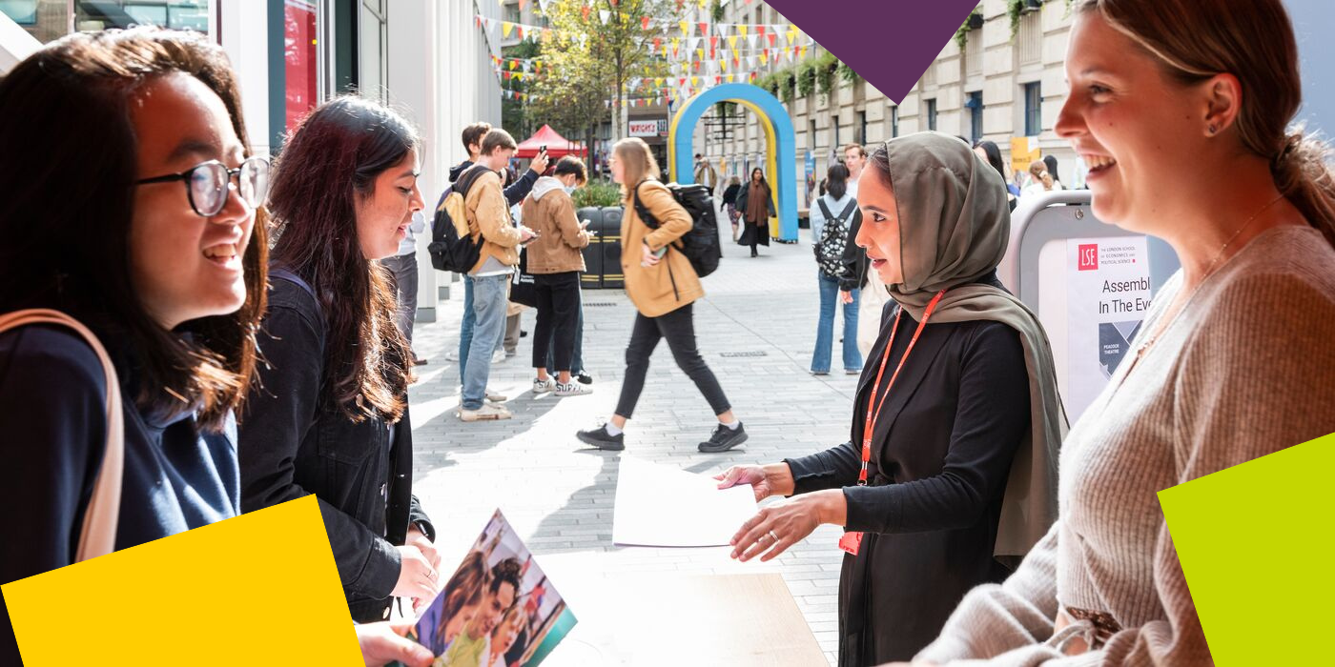

**MSc Human Rights and Politics**

You are part of a master’s programme that aims to engage with the most pressing issues facing global human rights and broader movements for social justice today. You will be welcomed into an intellectually diverse, exciting and international community of teachers and students in the Department of Sociology. With [LSE Human Rights](https://www.lse.ac.uk/sociology/human-rights) founded in 2000, you will join us as we celebrate our 25-year anniversary! Throughout the academic year, you will be invited to public events and activities at which you will meet cutting-edge scholars and practitioners engaged with global human rights and social justice today.  The Programme Director and teaching team look forward to meeting you and working with you next year.  We want to hear about your interests and your ideas, including the challenges that international human rights face today in your region or country.

**Programme Structure and Courses**

Students will take one compulsory course, choose optional courses to the value of two units, and write a dissertation. Optional courses to the value of one unit must be chosen from an approved list of Department of Sociology courses. The remaining optional courses can be chosen from an approved list of courses across LSE departments, including Sociology.

Please note that places are limited on some optional courses, and admission onto any course is not guaranteed and may be subject to timetabling constraints and/or students meeting specific prerequisite requirements.



**The Department of Sociology**

You are about to embark on an amazing journey, full of excitement, challenges, new knowledge, experiences, friends, and opportunities. The Department of Sociology is a community that brings people together from different parts of the world, speaking different languages and bringing their knowledge and unique experiences. This community includes your Programme Director and Programme Manager – the Sociology professional services staff, academic staff and associated teachers. We are here to support you in pursuing your academic and professional goals.

The Programme Manager for your degree will be your first point of contact for any queries throughout your time at LSE. Whether you need to know about the programme format, how to make your course choices, assessment matters, have general feedback, or if you’re just not sure who to contact at the school on any matter, please do get in contact and we will do our best to assist, or direct you the relevant colleague, or team.

**LSE Welcome**

Please note the date of the start of **LSE Welcome**, which is a programme of activities and events in-person on campus that will help you become part of LSE: **Monday 23 September – Friday 27 September 2024.** During this week, the department will be running a series of sessions that will allow you to learn about what to expect from your LSE education, prepare for the course selection process, and interact with your cohort. It will be an opportunity for you to get to know us better along with your classmates and the rest of the Department of Sociology community. **Please ensure you keep these dates free in your diary***.*

**Further Communications**

To make your admissions process as smooth as possible, look out for emails from [LSE's](https://lse.bmetrack.com/c/l?u=BD092BC&e=11E595F&c=ACD70&t=0&email=kpM4Fw09Tnma1TTtF%2BQvcA%3D%3D&seq=1)[Graduate Admissions Team](https://lse.bmetrack.com/c/l?u=BD092BC&e=11E595F&c=ACD70&t=0&email=kpM4Fw09Tnma1TTtF%2BQvcA%3D%3D&seq=2) who will continue to send you regular updates and reminders. The latest admission updates can be found on the School’s [News and Events webpage](https://www.lse.ac.uk/study-at-lse/Graduate/News). Be sure to pay close attention to the inevitable administrative priorities, as some messages will require action from you!

We will continue to be in contact with more programme information via these newsletters throughout the summer, and you can keep up to date with us via [our Offer Holders webpages.](https://www.lse.ac.uk/sociology/offer-holders/offer-holders)

Congratulations again, and we very much look forward to welcoming you and supporting you throughout your journey at LSE.

If you have any questions, please don’t hesitate to get in touch with us.

Best wishes,

**Dr Mahvish Ahmad**

**Programme Director for MSc Human Rights and Politics 2023-24**

**Department of Sociology**

The London School of Economics and Political Science

Houghton Street, London WC2A 2AE

e: [m.ahmad14@lse.ac.uk](mailto:m.ahmad14@lse.ac.uk)

**lse.ac.uk**

[](https://www.lse.ac.uk/)

[Twitter](https://twitter.com/LSEnews) [Facebook](https://www.facebook.com/lseps)  [Instagram](https://www.instagram.com/londonschoolofeconomics/)  [LinkedIn](https://www.linkedin.com/school/london-school-of-economics)  [](https://www.youtube.com/channel/UCK08_B5SZwoEUk2hDPMOijQ) [Tik Tok](https://www.tiktok.com/@lse)