

Dear Offer Holder,

The LSE Department of Sociology is very much looking forward to your enrolment. To get you introduced, please read below to find out more about your programme and the department.

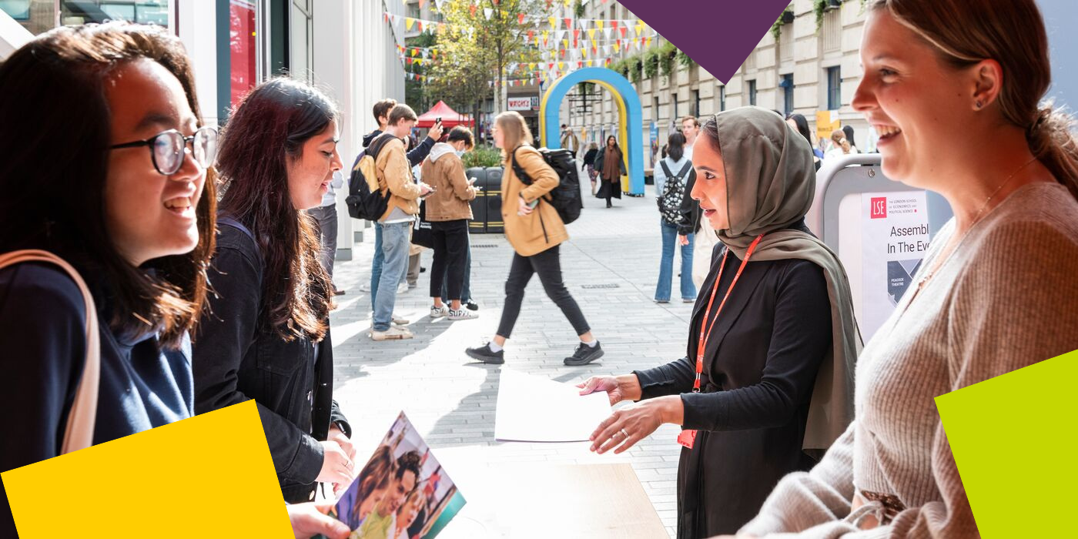

**MSc Human Rights**

During the coming year, you will explore some of the key human rights issues important in the world today with our programme’s unique interdisciplinary approach. The core course SO424 provides you with rigorous grounding in three different approaches to human rights, introducing you to discussions about human rights in political philosophy, in sociology and in law. In the option courses and in your dissertation, you will study some of these approaches in more depth and follow your interest in specific issues and regions.

LSE is a stimulating place to study; as one of the world's leading social science universities, we are engaged with global conversations and have an international outlook. We know that in your time with us you will pursue existing interests, but also discover new ones, and that you will learn in expected and unexpected ways.

**Programme Structure and Courses**

Students will take one compulsory course, choose optional courses to the value of two units, and write a dissertation. Optional courses to the value of one unit must be chosen from an approved list of Department of Sociology courses. The remaining optional courses can be chosen from an approved list of courses across LSE departments, including Sociology.

Please note that places are limited on some optional courses, and admission onto any course is not guaranteed and may be subject to timetabling constraints and/or students meeting specific prerequisite requirements.



**The Department of Sociology**

You are about to embark on an amazing journey, full of excitement, challenges, new knowledge, experiences, friends, and opportunities. The Department of Sociology is a community that brings people together from different parts of the world, speaking different languages and bringing their knowledge and unique experiences. This community includes your Programme Director and Programme Manager, the Sociology professional services staff, academic staff and associated teachers. We are here to support you in pursuing your academic and professional goals.

The Programme Manager for your degree will be your first point of contact for any queries throughout your time at LSE. Whether you need to know about the programme format, how to complete your course selection, assessment matters, have general feedback, or if you’re just not sure who to contact at the school on any matter, please do get in contact and we will do our best to assist, or direct you the relevant team.

**LSE Welcome**

Please note the date of the start of **LSE Welcome**, which is a programme of activities and events in-person on campus that will help you become part of LSE: **Monday 23 September – Friday 27 September 2024.** During this week, the department will be running a series of sessions that will allow you to learn about what to expect from your LSE education, prepare for the course selection process, and interact with your cohort. It will be an opportunity for you to get to know us better along with your classmates and the rest of the Department of Sociology community. **Please ensure you keep these dates free in your diary***.*

**Further Communications**

To make your admissions process as smooth as possible, look out for emails from [LSE's](https://lse.bmetrack.com/c/l?u=BD092BC&e=11E595F&c=ACD70&t=0&email=kpM4Fw09Tnma1TTtF%2BQvcA%3D%3D&seq=1)[Graduate Admissions Team](https://lse.bmetrack.com/c/l?u=BD092BC&e=11E595F&c=ACD70&t=0&email=kpM4Fw09Tnma1TTtF%2BQvcA%3D%3D&seq=2) who will continue to send you regular updates and reminders. The latest admission updates can be found on the School’s [News and Events webpage](https://www.lse.ac.uk/study-at-lse/Graduate/News). Be sure to pay close attention to the inevitable administrative priorities, as some messages will require action from you!

We will continue to be in contact with more programme information via these newsletters throughout the summer, and you can keep up to date with us via [our Offer Holders webpages.](https://www.lse.ac.uk/sociology/offer-holders/offer-holders)

Congratulations again, and we very much look forward to welcoming you and supporting you throughout your journey at LSE.

If you have any questions, please don’t hesitate to get in touch with us.

Best Wishes,

**Dr Ayça Çubukçu and Dr Mai Taha**

**Programme Directors for MSc Human Rights 2023-24**

**Department of Sociology**

The London School of Economics and Political Science

Houghton Street, London WC2A 2AE

e: [m.taha2@lse.ac.uk](mailto:m.taha2@lse.ac.uk), and [a.cubukcu@lse.ac.uk](mailto:a.cubukcu@lse.ac.uk)

**lse.ac.uk**

[](https://www.lse.ac.uk/)

[Twitter](https://twitter.com/LSEnews) [Facebook](https://www.facebook.com/lseps)  [Instagram](https://www.instagram.com/londonschoolofeconomics/)  [LinkedIn](https://www.linkedin.com/school/london-school-of-economics)  [](https://www.youtube.com/channel/UCK08_B5SZwoEUk2hDPMOijQ) [Tik Tok](https://www.tiktok.com/@lse)