

Dear Offer Holder,

The LSE Department of Sociology is very much looking forward to your enrolment. To get you introduced, please read below to find out more about your programme and the department.

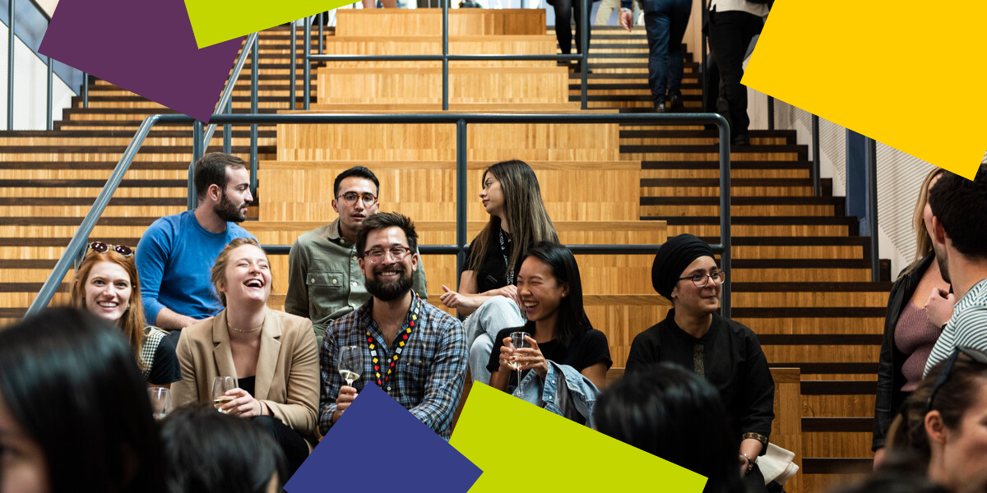

**MSc City Design and Social Science**  
Welcome to MSc City Design and Social Science! Our programme combines an exciting and diverse range of learning experiences and explores the connections between the social and spatial. We examine how design shapes urban space, responds to urban problems, creates possibilities for transformation, and integrates critical and practical approaches to the city. We foreground an immersive and interdisciplinary approach to studying the city, with a studio research and design module at the core. Our studio module explores transformational design projects, including site visits and a short fieldtrip within the UK. Our studio learning is also developed through group work and site-based study in London. We offer a number of options within our programme focussed on theory, policy and other areas, and students are also able to select courses from a range of recommended options across LSE, depending on the availability for that year.

The MSc degree draws students from different academic and professional backgrounds, reflecting the range of skills involved in urban policy, design and development today: architecture, engineering, planning and transport studies; social sciences and policy studies; geography and environmental science; law and humanities; journalism; activism and politics; business and management; real estate and finance. This rewarding programme aims to promote interdisciplinary practitioners, academics, and professionals who will engage with the city in a holistic manner and have a positive impact on the production of the urban environment.

**The Department of Sociology**

You are about to embark on an amazing journey, full of excitement, challenges, new knowledge, experiences, friends, and opportunities. The Department of Sociology is a community that brings people together from different parts of the world, speaking different languages and bringing their knowledge and unique experiences. This community includes your Programme Director and Programme Manager – and the Sociology professional services staff, academic staff and associated teachers. We are here to support you in pursuing your academic and professional goals.

The Programme Manager for your degree will be your first point of contact for any queries throughout your time at LSE. Whether you need to know about the programme format, how to make your course choices, assessment matters, have general feedback, or if you’re just not sure who to contact at the school on any matter, please do get in contact and we will do our best to assist, or direct you the relevant team.

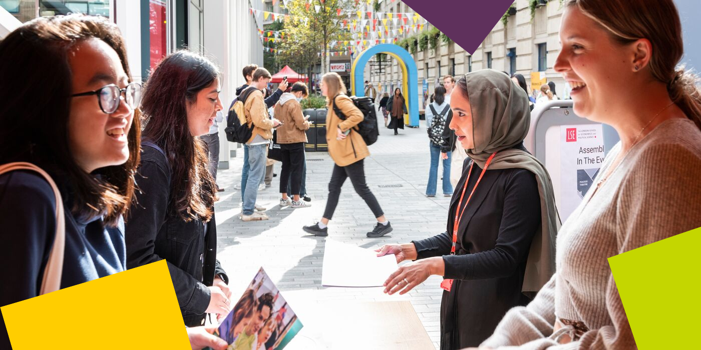

**LSE Welcome**

Please note the date of the start of **LSE Welcome**, which is a programme of activities and events in-person on campus that will help you become part of LSE: **Monday 23 September – Friday 27 September 2024.** During this week, the department will be running a series of sessions that will allow you to learn about what to expect from your LSE education, prepare for the course selection process, and interact with your cohort. It will be an opportunity for you to get to know us better along with your classmates and the rest of the Department of Sociology community. **Please ensure you keep these dates free in your diary***.*

**Further Communications**

To make your admissions process as smooth as possible, look out for emails from [LSE's](https://lse.bmetrack.com/c/l?u=BD092BC&e=11E595F&c=ACD70&t=0&email=kpM4Fw09Tnma1TTtF%2BQvcA%3D%3D&seq=1)[Graduate Admissions Team](https://lse.bmetrack.com/c/l?u=BD092BC&e=11E595F&c=ACD70&t=0&email=kpM4Fw09Tnma1TTtF%2BQvcA%3D%3D&seq=2) who will continue to send you regular updates and reminders. The latest admission updates can be found on the School’s [News and Events webpage](https://www.lse.ac.uk/study-at-lse/Graduate/News). Be sure to pay close attention to the inevitable administrative priorities, as some messages will require action from you!

We will continue to be in contact with more programme information via these newsletters throughout the summer, and you can keep up to date with us via [our Offer Holders webpages.](https://www.lse.ac.uk/sociology/offer-holders/offer-holders)

Congratulations again, and we very much look forward to welcoming you and supporting you throughout your journey at LSE.

If you have any questions, please don’t hesitate to get in touch with us.

Best Wishes,

**Dr David Madden**

**Programme Director for MSc City Design and Social Science**

**Department of Sociology**

The London School of Economics and Political Science

Houghton Street, London WC2A 2AE

e: [d.j.madden@lse.ac.uk](mailto:d.j.madden@lse.ac.uk)

[](https://www.lse.ac.uk/)

[Twitter](https://twitter.com/LSEnews) [Facebook](https://www.facebook.com/lseps)  [Instagram](https://www.instagram.com/londonschoolofeconomics/)  [LinkedIn](https://www.linkedin.com/school/london-school-of-economics)  [](https://www.youtube.com/channel/UCK08_B5SZwoEUk2hDPMOijQ) [Tik Tok](https://www.tiktok.com/@lse)