

Dear Offer Holder,

The LSE Department of Sociology is very much looking forward to your enrolment. To get you introduced, please read below to find out more about your programme and the department.

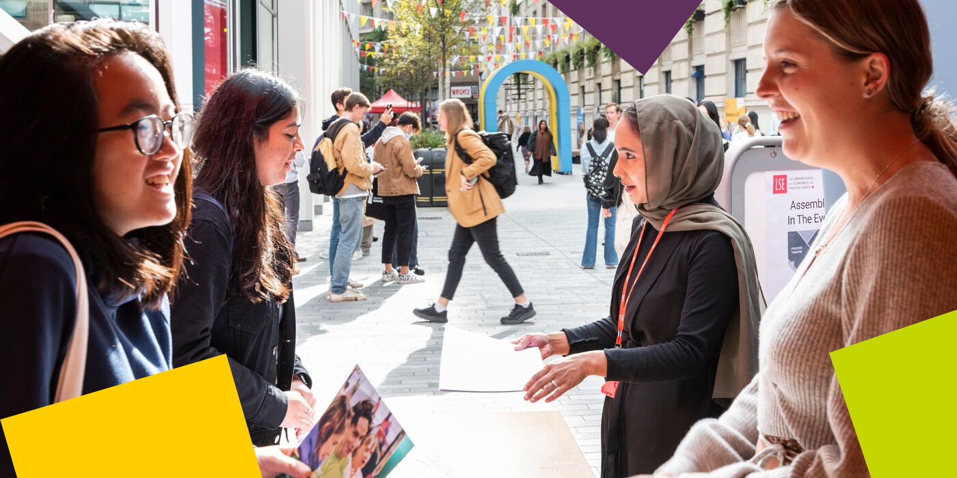

**Programme Structure and Courses**

The MSc in Economy and Society programme caters to a unique combination of intellectual interests. It is an advanced sociology degree, which examines economic life as intertwined with political, cultural, organisational, and technological concerns. Understanding the global risks and possibilities confronted by contemporary societies – from climate change to financialisation to technological change – requires grasping the role and dynamics of economies as social arenas in which power, knowledge and culture shape action and actors.

The programme is unique in its breadth and diversity. It covers the most significant and recent developments in the sociology of economic life. A compulsory course in Economic Sociology will introduce you to critical discussions on the nature of power in the economy, the production of knowledge and expertise, capitalist relations, value and culture, relations of credit and debt and the social structures of markets. Through optional courses, you can further specialise in the sociology of markets, risk governance, material culture, the sociology of consumption, and the sociology of science and technology (subject to availability). The programme will enable you to develop critical skills that advance your knowledge of the socio-economic dynamics of contemporary societies.

Tying all this together is a core commitment to a broadly based sociological approach to questions that are often addressed by narrower approaches drawn from disciplines such as economics, finance and law. If you haven’t studied sociology before, we urge you to develop your understanding of the discipline by focusing on appropriate reading and participating actively in lectures and seminars.



**The Department of Sociology**

You are about to embark on an amazing journey, full of excitement, challenges, new knowledge, experiences, friends, and opportunities. The Department of Sociology is a community that brings people together from different parts of the world, speaking different languages and bringing their knowledge and unique experiences. This community includes your Programme Director and Programme Manager, the Sociology professional services staff, academic staff and associated teachers. We are here to support you in pursuing your academic and professional goals.

The Programme Manager for your degree will be your first point of contact for any queries throughout your time at LSE. Whether you need to know about the programme format, how to complete your course selection, assessment matters, have general feedback, or if you’re just not sure who to contact at the school on any matter, please do get in contact and we will do our best to assist, or direct you the relevant colleague, or team.

**LSE Welcome**

Please note the date of the start of **LSE Welcome**, which is a programme of activities and events in-person on campus that will help you become part of LSE: **Monday 23 September – Friday 27 September 2024.** During this week, the department will be running a series of sessions that will allow you to learn about what to expect from your LSE education, prepare for the course selection process, and interact with your cohort. It will be an opportunity for you to get to know us better along with your classmates and the rest of the Department of Sociology community. **Please ensure you keep these dates free in your diary***.*

**Further Communications**

To make your admissions process as smooth as possible, look out for emails from [LSE's](https://lse.bmetrack.com/c/l?u=BD092BC&e=11E595F&c=ACD70&t=0&email=kpM4Fw09Tnma1TTtF%2BQvcA%3D%3D&seq=1)[Graduate Admissions Team](https://lse.bmetrack.com/c/l?u=BD092BC&e=11E595F&c=ACD70&t=0&email=kpM4Fw09Tnma1TTtF%2BQvcA%3D%3D&seq=2) who will continue to send you regular updates and reminders. The latest admission updates can be found on the School’s [News and Events webpage](https://www.lse.ac.uk/study-at-lse/Graduate/News). Be sure to pay close attention to the inevitable administrative priorities, as some messages will require action from you!

We will continue to be in contact with more programme information via these newsletters throughout the summer, and you can keep up to date with us [via our Offer Holders webpages.](https://www.lse.ac.uk/sociology/offer-holders/offer-holders)

Congratulations again, and we very much look forward to welcoming you and supporting you throughout your journey at LSE.

If you have any questions, please don’t hesitate to get in touch with us.

Best Wishes,

**Dr Rebecca Elliott**

**Programme Director for MSc Economy and Society 2023-24**

**Department of Sociology**

The London School of Economics and Political Science

Houghton Street, London WC2A 2AE

**e**: [r.elliott1@lse.ac.uk](mailto:r.elliott1@lse.ac.uk)

**lse.ac.uk**

[](https://www.lse.ac.uk/)

[Twitter](https://twitter.com/LSEnews) [Facebook](https://www.facebook.com/lseps)  [Instagram](https://www.instagram.com/londonschoolofeconomics/)  [LinkedIn](https://www.linkedin.com/school/london-school-of-economics)  [](https://www.youtube.com/channel/UCK08_B5SZwoEUk2hDPMOijQ) [Tik Tok](https://www.tiktok.com/@lse)