
Dear %studentname,

We wanted to let you know of key dates for your diary so you know when you will need to be on campus and can start preparing your arrival plans. Welcome - LSE’s introductory week for all new students - will be taking place from Monday 23 to Friday 27 September 2024. There will be both department and LSE-wide events running throughout that week, and we cannot wait to meet you and to welcome you on campus and into our student community.

We may have met some of you recently - in April this year, LSE held our Offer Holders Day, and the department hosted a taster lecture and Q&A. It was brilliant to see so many of you there and engage in conversation about the department and your interests in Sociology. For those that were unable to make it, the taster lecture led by our BSc Programme Director, Dr. Sara Salem, was recorded and is available to view here.

September is just around the corner, and we wanted to formally introduce you to our current programme director, Sara. If you were able to attend our Offer Holders Day, you will have met her and a few others members from the department already! They will be integral to supporting you during your BSc Programme and we’ll send you more information in the coming months.

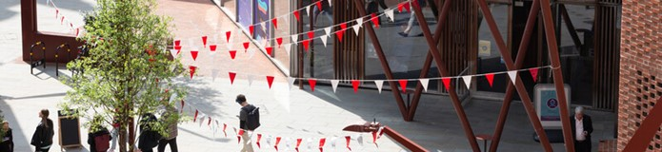
________________________________________

Welcome to the BSc Sociology here at LSE and what we are confident will be the start of an exciting three-year adventure of learning and exploration.

The BSc Sociology is the flagship degree offered by the department. Our research spans across many critical issues shaping the world today, and through a combination of lectures, seminars, workshops and events, we will draw on this expertise to inspire in you a passion for the discipline and the possibilities of the sociological imagination. This will certainly be challenging: you’ll have to deal with new types of knowledge, collaborate with your peers in novel ways, and critically assess some of the most profound taken-for-granted assumptions of the modern world. But we’re also confident it will be a rewarding, mind-expanding experience: you will learn to create, collaborate and think in new and critical ways.

You have been selected from a large pool of applicants. We have chosen you not only because of your academic ability but also because of the skills and diverse life experiences you’ll bring to the degree. At LSE, you’ll be part of a relatively small cohort of students and will be in close proximity to our faculty and staff. We expect you to work closely with us and your peers and to exhibit the highest standard of integrity and dedication to the degree. This is a fascinating adventure, but it is one that requires work and dedication.
I look forward to meeting you all in person and wish you the best in your experience at LSE.
Dr. Sara Salem
BSc Programme Director (2023-24), LSE Sociology
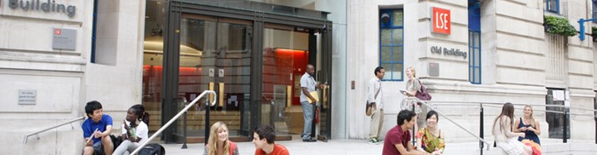

The Department of Sociology

You are about to embark on an amazing journey, full of excitement, challenges, new knowledge, experiences, friends, and opportunities. The Department of Sociology is a community that brings people together from different parts of the world, speaking different languages and bringing their knowledge and unique experiences. This community includes your Programme Director and Programme Manager – and the Sociology professional services staff, academic staff and all LSE associated teachers. We are happy to be there to support you in pursuing your academic and professional goals.

Undergraduate Programme Manager

The Programme Manager for your degree will be your first point of contact for any queries you may have throughout your time at LSE. Whether you need to know about the programme format, how to make your course choices, assessment matters, have general feedback, or if you’re just not sure who to contact at the school on any matter, please do get in contact and we will do our best to assist, or direct you the relevant colleague or team.



Monika Walker (she/her)
Undergraduate Programme Manager | Department of Sociology
The London School of Economics and Political Science
Houghton Street, London WC2A 2AE
e: sociology.ug@lse.ac.uk




