
Dear %studentname,
On behalf of the Department of Sociology at LSE, we would like to congratulate you on your offer to study BSc Sociology with us.
We understand that transitioning into undergraduate study is a significant and life-changing moment, so we want to offer you as much help and support as possible. We know you now have some important decisions ahead of you and want you to feel confident and well-equipped with the knowledge you need to make well-informed choices for your university life and beyond.
As an Offer Holder, you can find some useful information about LSE and what to do next here, as well as guidance on who to contact if you have specific questions about your offer or related processes. If you have questions relating to the Department of Sociology or your programme, you can always contact us and we’ll be happy to help you.
Offer Holders Day 24 April 2024
The Offer Holders’ Day gives undergraduate applicants with an offer of admission the opportunity to visit the LSE campus, meet LSE students and staff, and find out more about studying at LSE and life in London.
Our next Undergraduate Offer Holders’ Day will be held on Wednesday 24 April 2024 for applicants with an offer for entry in September 2024. See the Offer Holders' Day event page for further information to book a place.
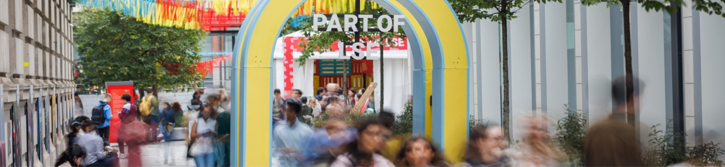
Joining Our Community
Rather than wait until September, we want you to consider yourself a member of our community right now.
If you haven’t already, take some time to explore our departmental website to get a feel for the sort of work we engage in, the events we hold, and what we strive for collectively as a department. We are very active on social media, so be sure to follow us on X, Facebook, LinkedIn and Instagram.
As a department comprising approximately 30 full-time academics and teaching fellows, 15 Graduate Teaching Assistants, 9 Professional Support Staff members, and around 400 students, we work collectively to foster a diverse, close-knit and supportive environment where students and staff can engage in socially relevant, critical and creative learning and scholarship.
Our work as a department spans across many key issues shaping our world today, in empirically rich sociological analysis at the intersections between economy, politics and society.
We examine social inequalities, economic and political change, human rights challenges, migration, urbanisation, technological transformation, climate issues, and much more.
As an active, socially conscious, and engaged community, we strive to offer our students rigorous training in theoretical and methodological sociological inquiry. Our ultimate goal is to provide you with some of the most valuable transferable skills needed for our modern society: critical, committed, independent thought.

What To Expect Next
In the months leading up to the start of your course, we will keep in regular contact with you, providing information on a range of exciting topics including Welcome, course selection, news about the Department, upcoming events, ways to get involved, and things to prepare in the lead up to the start of your degree.
See You In September
It is our sincere hope that you choose to make the Department of Sociology at LSE your academic home for the duration of your degree. During your time studying with us, we are committed to supporting your development of the skills that will enable you to engage with your environment in meaningful ways to help understand, shape and change the world.
We look forward to welcoming you to the Department at the start of the academic year in September.
Best wishes,
Professor Suzi Hall
Head of the Department of Sociology
LSE
