A Say in the End of the World: Peace and Anti-Nuclear Solidarity in the 1980s
16th July 1945, the day the world entered the age of the atom bomb with the carrying out of the first test in the United States. Since then, the world has lived in the age of nuclear weapons with all its associated politics. From the perspective of the United States, some of this history is covered in four collections available via the Digital National Security Archive and via US Declassified Documents Online:
- U.S. Nuclear History, 1969-1976: Weapons, Arms Control, and War Plans in an Age of Strategic Parity
- U.S. Nuclear History: Nuclear Arms and Politics in the Missile Age, 1955–1968
- U.S. Nuclear Nonproliferation 2, Part I: From Atoms for Peace to the NPT, 1954-1968
- U.S. Nuclear Nonproliferation Policy, 1945–1991
However, these collections do not engage with the anti-nuclear movement, though one document in US Declassified Documents Online discusses the need for a US public affairs initiative to persuade the British public to agree with US policy. It advises that particular attention should be paid to countering the ‘women of Greenham Common’.
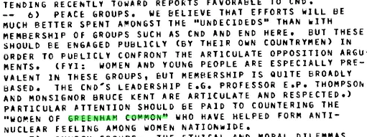
The issue of nuclear weapons as the exhibition text details divided opinion, just like the policies pursue by the Conservative government of Margaret Thatcher in the early 1980s. The exact nature of these policies and divisions can be discovered using UK Parliamentary Papers, which includes Hansard. These included questions on the cost of the protests, the activities of senior civil servants or being absent from parts of debates to be at CND meetings.
Parliament was one forum for debates surrounding British nuclear policy. The Royal Institute for International Affairs was another and its records via Chatham House Online Archive shed further light on the general international situation in the 1980s. One publication issued as a Chatham House Special Paper was ‘The Nuclear Debate: Issues and Politics’. This examined the nuclear debate, arms control, and the state of the peace movement in Britian and continental Europe. Christopher Coker, the former head of LSE ideas wrote the chapter on Britain and notes the links between the various groups.
The links identified in the chapter by Coker are further demonstrated in the Greenham Common and Campaign for Nuclear Disarmament records, which make reference to the encampment. This includes the Greenham Women Everywhere collection available on the LSE Digital Library.

The peace movements of the 1980s were widely reported in the British media with a range of articles published about CND. A 1980s article published in The Times questioned whether CND stood more of a chance at succeeding than in its early years’, a possibility made easier due to Tory nuclear decisions. The early history of CND is covered in the book, The Protest Makers. In comparison, the Guardian published a series of letters in its issue on 4 December 1982. Within the letters it becomes clear that CND contains a wide range of opinions from differing political viewpoints.
Away from primary sources, a major source for finding secondary literature on the subject is Peace Research Abstracts. A search for the pressure groups and people mentioned in the introduction to the exhibition gives the following results:
- Campaign for Nuclear Disarmament – 128, which includes a review of the history of the CND archive at LSE
- Campaign Against Arms Trade – 4
- Women for Families and Defence – 0
- Pat Arrowsmith - 4

