URKEW’s SPRING CONFERENCE 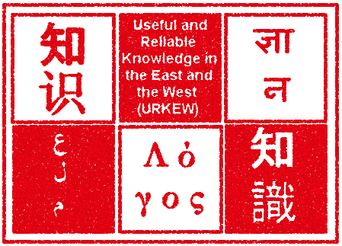
at Cumberland Lodge, Windsor Great Park
08 -11 May, 2011

“Institutions for Higher and Vocational Forms of Education and their Connexions with the Formation, Promotion, Development and Diffusion of Useful and Reliable Knowledge in the East and the West c.1350 to c.1850”

Arrival Day - Sunday 08 May
Arrival for evening dinner at 19.00 followed by a plenary lecture at 20.45 : “Why did the Dialogue of Civilizations culminate in a Scientific Revolution in the West?” by Arun Bala (Institute of Southeast Asian Studies, Singapore)

Day One – Monday 09 May

08.00 Breakfast

Session One 09.00 – 11.00 Europe : Laurence Brockliss (Oxford)

11.00 – 11.30 Coffee

Session Two 11.30 – 13.00 Islamdom: Ahmet Karamustafa
(Washington, St Louis)

13.00 – 15.00 Lunch break

15.00 – 15.30 Tea

Session Three 15.30 – 17-30 China : Harriet Zurndorfer (Leiden)

17.30 – 19.15 Break

19.15 Dinner

Day Two – Tuesday 10 May

08.00 Breakfast

Session One 09.00 – 11.00 India : Prasanan Parthasarathi
(Boston)
11.00 – 11.30 Coffee

Session Two 11.30 – 13.00 Japan : Ron Dore (LSE)

13.00 – 15.00 Lunch break

15.00 – 15.30 Tea

Session Three 15.30 – 17-30 Islamdom and Europe: a comparison
Floris Cohen (Utrecht)

17.30 – 19.15 Break

19.15 Dinner

Day Three – Wednesday 11 May

08.00 Breakfast

Session One 09.00 – 11.00 Europe and China: a comparison
Roy Bin Wong (UCLA)

11.00 – 11.30 Coffee

Session Two 11.30 – 13.00 Roundtable:
William Clarence-Smith (SOAS)
David Washbrook (Cambs)
Mark Elvin (Oxford)

13.00 – 14.30 Lunch and farewell

Participants:

Janet Hunter (LSE) Sunday – Tuesday evening only
Tirthankar Roy (LSE)
Patrick Wallis (LSE) Sunday – Monday evening only
Kent Deng (LSE)
Angus Lockyer (SOAS)
Erik Reinert (Oslo)

URKEW team:

Patrick O’Brien PI
Mina Ishizu
Khodadad Rezhakani
Anjana Singh
Simona Valeriani
Ting Xu

Loraine Long (Administrator)

London School of Economics and Political Science
Houghton Street London WC2A 2AE, United Kingdom

